[WORKING WITH THE DATASET](https://careereducation.smartinternz.com/Student/guided_project_workspace/10708" \l "collapse1)

Downloading and Understanding the Dataset

|  |  |
| --- | --- |
| Team ID | PNT2022TMID22202 |
| Team Lead | Santhosh kumar .V |
| Team Members | Sharan R  Yogesh S  Yuvaganesh GK |
| Project Name | A New Hint to Transportation-Analysis of the NYC Bike Share System |

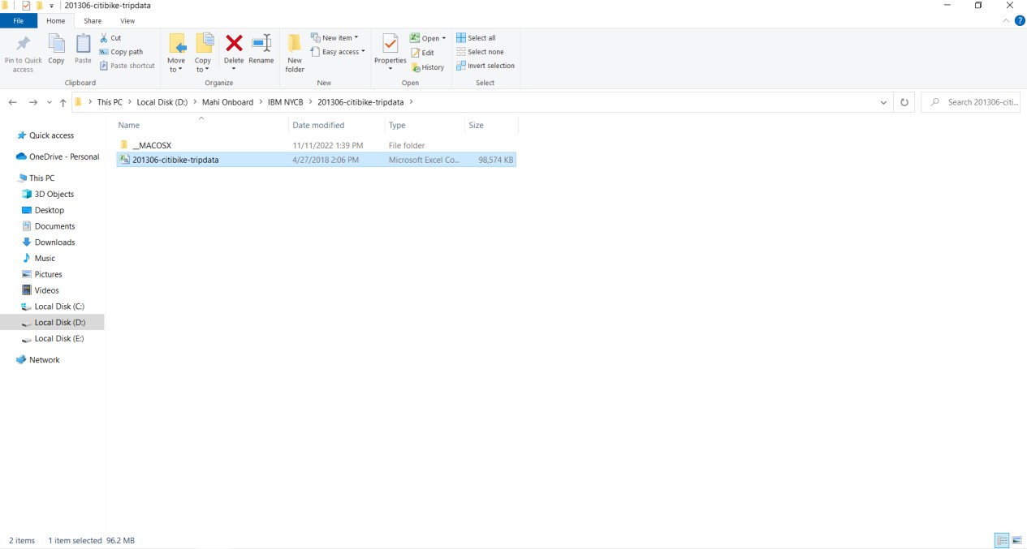Download the zip file from the dataset link and extract

Understanding the dataset

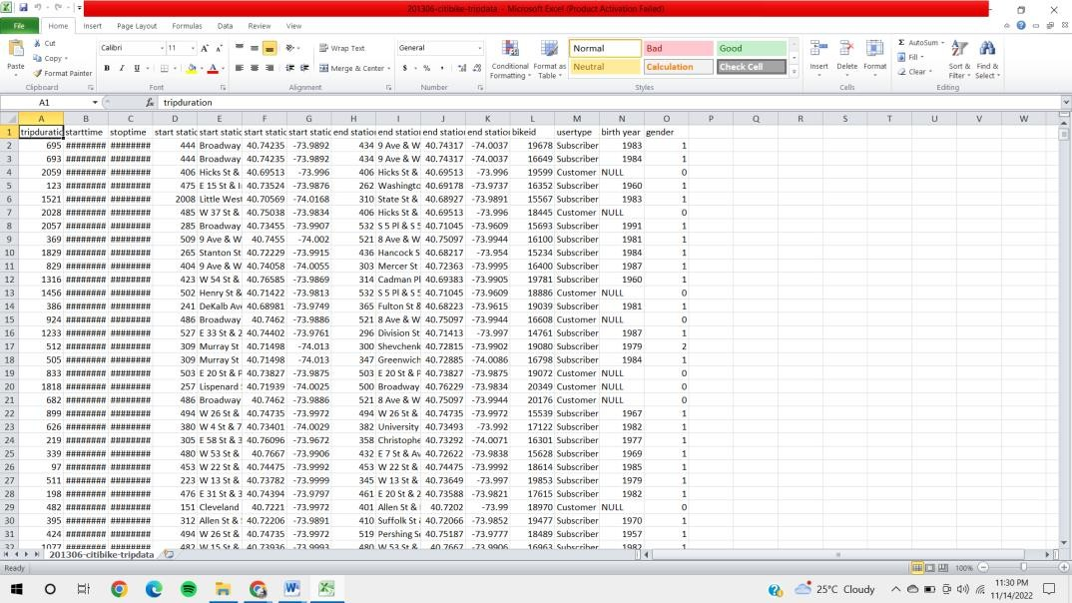

1. Trip Duration: How long a trip lasted in seconds2. Start Date and Time: EX->01-06-2013 00:00:01 3. Stop Date and Time: EX->01-06-2013 00:11:36

4. Start Station ID: Unique identifier for each station 5.Start Station Name

1. Start Station Latitude: Coordinates
2. Start Station Longitude: Coordinates
3. End Station ID: Unique identifier for each station
4. End Station Name
5. End Station Latitude 11.End Station Longitude
6. Bike ID: Unique identifier for each bike
7. User Type (Customer = 24-hour pass or 3-day pass user; Subscriber = Annual Member): Customers are usually tourists, subscribers are usually NYC residents
8. Year of Birth: Self-entered, not validated by an ID
9. Gender (Zero=unknown; 1=male; 2=female): Usually unknown for customers since they often sign up at a kiosk